Produce Inventory Manager
A simple C++ console application that reads a list of purchased items from a text file and tracks quantities of produce using object-oriented programming.
Author:
Alexandria D. Scott – SNHU – CS 210
Features:
- Reads items sold from text file (one item per line)
- Automatically groups identical items and counts occurrences
- Supports basic produce tracking
  - Name & quantity
  - Name & histogram
  - Search by name
- Creates backup file of item names and frequencies
Project Structure
Project_root/
|--Project3.cpp
|--Produce.h
|--Produce.cpp
|--Inventory.h
|--Inventory.cpp
|--Items_Shopped.txt
|--frequencies.dat

Example Usage
Input file Items_Shopped.txt
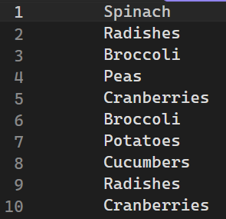
Name & quantity
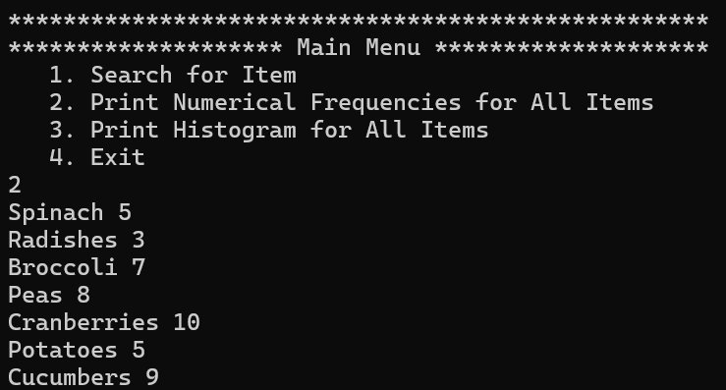
Name & histogram
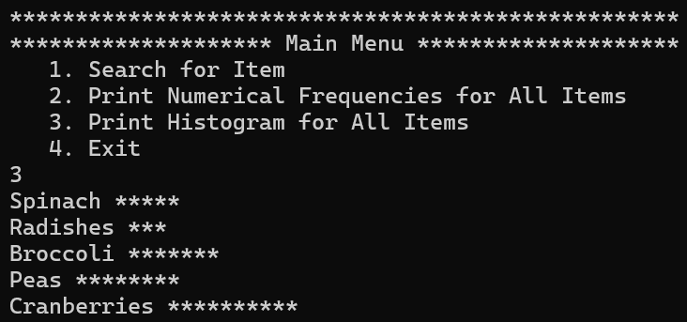
Search by name
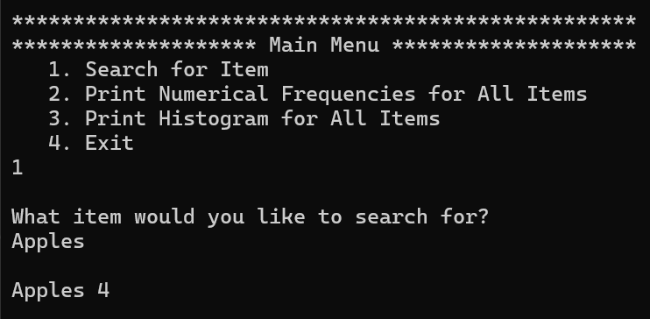
Backup file frequency.dat
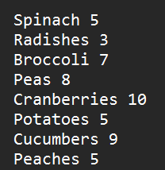
Project3.cpp
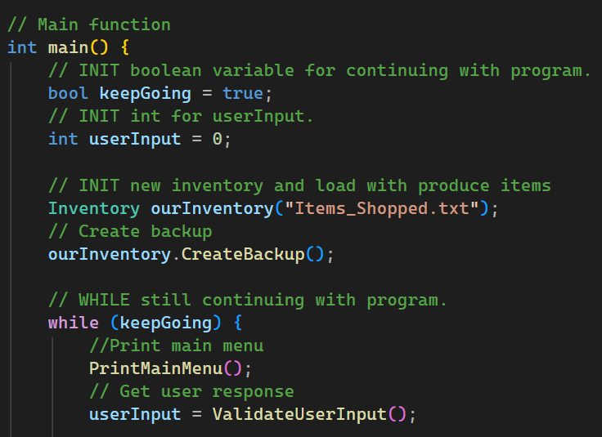
Inventory.cpp Example
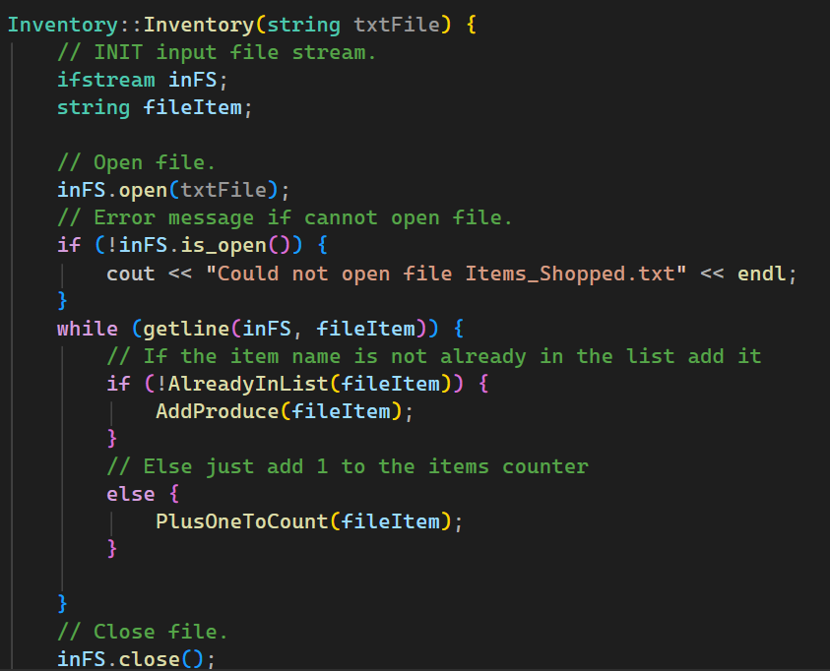
Produce.cpp Example
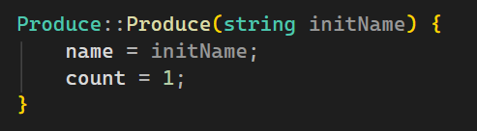
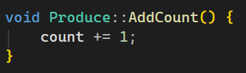
Design Overview
- Produce class represents one type of item (name & count)
- Inventory class manages a collection of Produce instances
  - Checks for duplicates
  - Increments count when item already exist
  - Prints names and counts of items
  - Searches based on name and displays information
- Creates backup in new file
- User interaction takes place in main function
Limitations
- Linear search will be slow for very large lists
- No sorting output ability
- Minimal error handling
  - Error handling for main menu is complete
  - No error handling for capitalization errors in search function
- No ability to change data from menu

